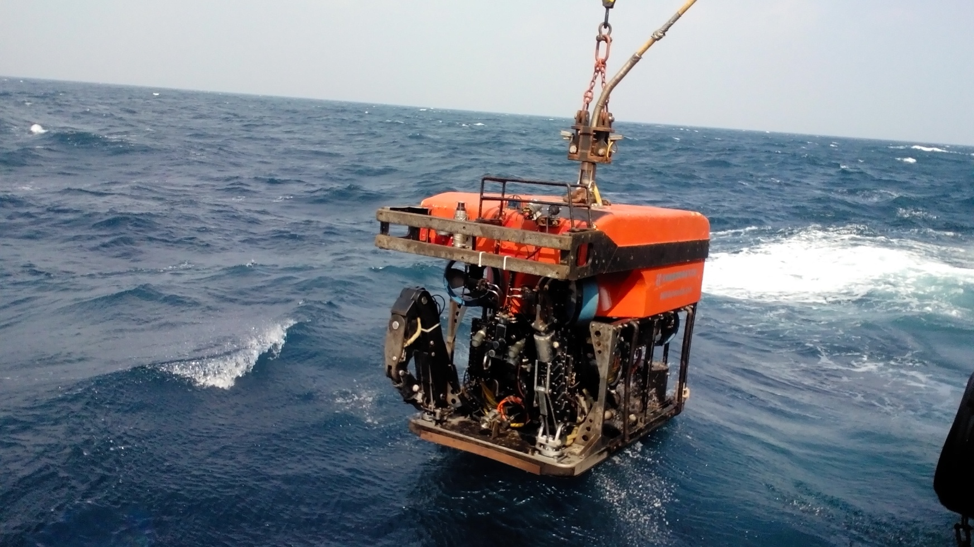

ROV VEHICLE

Swift-07 ROV System-150hp

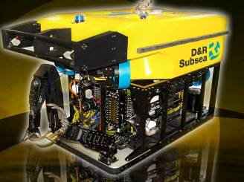
Depth Rating 1,000 meters
Total Power Rating 113kw/150hp

Dimensions & Weight

Length 2,500 mm
Width 1,450 mm
Height 1,800 mm
Weight In-air 2,700 kgs

Performance

Forward 300 kgf 3.5knots
Lateral 265 kgf 2.5knots
Vertical 225 kgf 2.0 knots
Turning Rate 40°/s @ rated depth
Standard Power Pack 150hp
MTQ 113kw/150hp shaft output power, 3 phases, 4 poles,
3KV motor, oil filled and compensated.
Vickers piston pump, output 220lpm @ 200bar

Payload (including manipulators)

Payload of Standard Vehicle 150 kgs
Optional Additional Payload 50 kgs
Through Frame Lift 2,500 kgs

Propulsion System

7 MTQ 350mm diameter 12.5kw/16.5hp hydraulic thrusters
individually servo valve controlled
Lateral 4 x 350 mm Ø thrusters
Vertical 3 x 350 mm Ø thrusters

Video & Telemetry System (Standard)

Transmission via fiber optics and copper
Fiber Optic, 3 video + 6 RS 232 / 485 channels
Copper, 3 Video + 8 Data Lines
Real-time Video Channels, 3 on Coax / 3 on Fiber

Pan & Tilt

MTQ Pan & Tilt Unit 1
Pan ±180°
Tilt ±180°
Second Pan & Tilt optional

Cameras

OE 1323 D SIT Camera 1
OE 1360 Color Camera 1
Still Camera with Flasher (optional)
Digital Still Camera & Flasher (optional)

Control & Navigation

Flux Gate Compass and Integrated Rate Gyro System 1
TritechSeaKing DFS Sonar system 1
MTQ Depth Transducer System 1

Power Packs & Tooling Interfaces (optional fit)

MTQ Hydraulic Power Pack 125hp
MTQ Tooling Power Pack 50hp
Schilling 7-Function Titan T3 Manipulator
Schilling 5-Function RigMaster Grabber Arm
Ragan Latch Override Tool
Guide Wire Cutter
75mm diameter Wire Rope Cutter
API Standard Hot Stabs
API Torque Tools
supplied on request.

UMBILICAL

The standard Aramid umbilical is 41mm in diameter
and has the following cores:
17 x 4mmsq 3kv Rated Power and Earth Cores
4x 75 ohm Coaxial
4 x Screened Twisted Quads
4 Single + 2 Multi Mode Fibers in a common loose tube
Standard length 650 meters, or 1200 meters optional

DECK CABLE

30m Deck cable from Control Van to Umbilical Winch

Swift-07 ROV System-150hp

CONTROL CONTAINER (A60, ZONE2 OPTIONAL)

Length 6,000 mm
Width 2,438 mm
Height 2,591 mm
Shipping Weight 7,000 kgs

WORKSHOP CONTAINER (A60, ZONE2OPTIONAL)

Length 6,000 mm
Width 2,440 mm
Height 2,774 mm
Shipping Weight 12,000 kgs
Complete inventory of system spares
Mechanical and electrics tools and test equipment

HANDLING SYSTEM (A60, ZONE 2 OPTIONAL)

Exd II BT4 Explosion-Proof Level

Hydraulic Marine Crane

SQ10ZA2M Model Marine Crane 1
Length 3,000 mm
Width 1,600 mm
Height 2,600 mm
Shipping Weight 5,000 kgs
Arm maximum reach 6,000 mm
Maximum lift capacity 10 t
Lift capacity @ full extension 3,200 kgs
Power Rating 30 kw

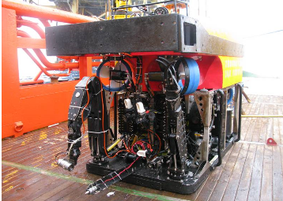

Umbilical Winch

243JC Model Marine Winch 1
Length 2,500 mm
Width 2,450 mm
Height 2,300 mm
Shipping Weight 6,000 kgs
Line Pull 1,300 kgf
Line Speed 0~30 m/min
Drum Capacity (Ф 35.5mm cable) ≥800 m

Hydraulic Power Pack for Handling System

Length 6,000 mm
Width 2,440 mm
Height 2,774 mm
Shipping Weight 12,000 kgs

SERVICERS

Power (total) 380/440V, 300A, 50/60Hz
Air (LP) optional for Zone II only

GENERATOR (OPTIONAL)

Capacity, 380/440V, 3phases, 50/60Hz
350kVA, 500A.

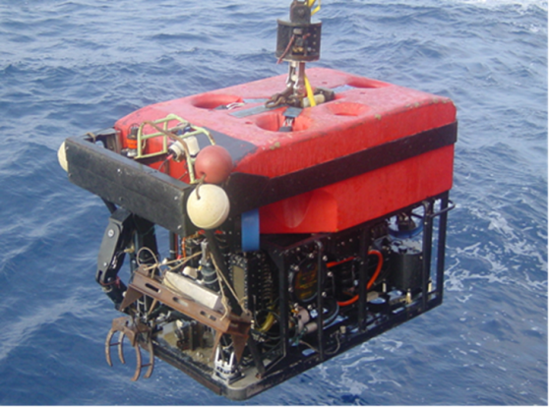

Depth Rating 1,000 meters
Total Power Rating 94kw/125hp

Dimensions & Weight

Length 2,500 mm
Width 1,450 mm
Height 1,800 mm
Weight In-air 2,700 kgs

Performance

Forward 300 kgf 3.5knots
Lateral 265 kgf 2.5knots
Vertical 225 kgf 2.0 knots
Turning Rate 40°/s @ rated depth
Standard Power Pack 150hp
MTQ 94kw/125hp shaft output power, 3 phases, 4 poles,
3KV motor, oil filled and compensated.
Vickers piston pump, output 220lpm @ 200bar

Payload (including manipulators)

Payload of Standard Vehicle 150 kgs
Optional Additional Payload 50 kgs
Through Frame Lift 2,500 kgs

Propulsion System

7 MTQ 350mm diameter 12.5kw/16.5hp hydraulic thrusters
individually servo valve controlled
Lateral 4 x 350 mm Ø thrusters
Vertical 3 x 350 mm Ø thrusters

Video & Telemetry System (Standard)

Transmission via fiber optics and copper
Fiber Optic, 3 video + 6 RS 232 / 485 channels
Copper, 3 Video + 8 Data Lines
Real-time Video Channels, 3 on Coax / 3 on Fiber

Pan & Tilt

MTQ Pan & Tilt Unit 1
Pan ±180°
Tilt ±180°
Second Pan & Tilt optional

Cameras

OE 1323 D SIT Camera 1
OE 1360 Color Camera 1
Still Camera with Flasher (optional)
Digital Still Camera & Flasher (optional)

Swift-01 ROV System-125hp

Control & Navigation

Flux Gate Compass and Integrated Rate Gyro System 1
TritechSeaKing DFS Sonar system 1
MTQ Depth Transducer System 1

Power Packs & Tooling Interfaces (optional fit)

MTQ Hydraulic Power Pack 125hp
MTQ Tooling Power Pack 50hp
Schilling 7-Function Titan T3 Manipulator
Schilling 5-Function RigMaster Grabber Arm
Ragan Latch Override Tool
Guide Wire Cutter
75mm diameter Wire Rope Cutter
API Standard Hot Stabs
API Torque Tools
supplied on request.

UMBILICAL

The standard Aramid umbilical is 41mm in diameter
and has the following cores:
17 x 4mmsq 3kv Rated Power and Earth Cores
4x 75 ohm Coaxial
4 x Screened Twisted Quads
4 Single + 2 Multi Mode Fibers in a common loose tube
Standard length 650 meters, or 1200 meters optional

DECK CABLE

30m Deck cable from Control Van to Umbilical Winch

Swift-01 ROV System-125hp

CONTROL CONTAINER (A60, ZONE2 OPTIONAL)

Length 6,000 mm
Width 2,438 mm
Height 2,591 mm
Shipping Weight 7,000 kgs

WORKSHOP CONTAINER (A60, ZONE2OPTIONAL)

Length 6,000 mm
Width 2,440 mm
Height 2,774 mm
Shipping Weight 12,000 kgs
Complete inventory of system spares
Mechanical and electrics tools and test equipment

HANDLING SYSTEM (A60, ZONE 2 OPTIONAL)

Exd II BT4 Explosion-Proof Level

Hydraulic Marine Crane

SQ10ZA2M Model Marine Crane 1
Length 3,000 mm
Width 1,600 mm
Height 2,600 mm
Shipping Weight 5,000 kgs
Arm maximum reach 6,000 mm
Maximum lift capacity 10 t
Lift capacity @ full extension 3,200 kgs
Power Rating 30 kw

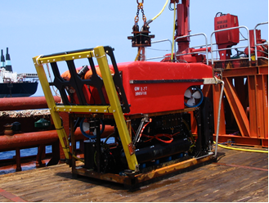

Umbilical Winch

243JC Model Marine Winch 1
Length 2,750 mm
Width 2,440 mm
Height 2,590 mm
Shipping Weight 6,000 kgs
Line Pull 1,300 kgf
Line Speed 0~30 m/min
Drum Capacity (Ф 35.5mm cable) ≥800 m

Hydraulic Power Pack for Handling System

Length 6,000 mm
Width 2,440 mm
Height 2,774 mm
Shipping Weight 12,000 kgs

SERVICERS

Power (total) 380/440V, 300A, 50/60Hz
Air (LP) optional for Zone II only

GENERATOR (OPTIONAL)

Capacity, 380/440V, 3phases, 50/60Hz
350kVA, 500A.

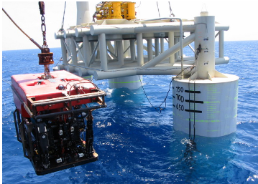

MAJAVE Observation class ROV

Type

300 meters depth rating

Manufacturer

MTQSubsea Technology Pte Ltd

Depth Rating

Standard Depth rating 300 meters

Propulsion system

5 SPE-75 brushless direct current propellers
Propulsion mode Vernier Thruster

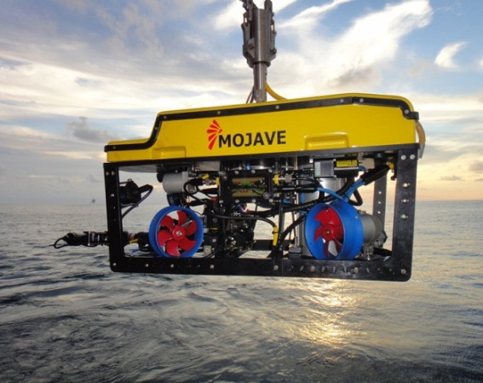

Dimensions & Weight
Length 1000 mm
Width 600 mm
Height 500 mm
Weight In-air(self-weight) 85 kg
Length of umbilical 350 meters

Performance
Forward 63kgf
Lateral 63kgf
Vertical 26kgf

Power requirement
3.6 KW, 90V-230Valternating current

